EXPT NO: 9 | MINI PROJECT  HEALTHCARE DATAANALYTICS

AIM:
To analyze Indian healthcare data using MySQL and Power BI by managing a 20,000record healthcare dataset, performing data analysis using SQL queries, and creating interactive visualizations to identify trends in patient demographics, diseases, medical conditions, treatments, treatment outcomes, BMI, blood glucose, HbA1c levels, regions, and insurance coverage.
Software and Tools Required
- MySQL
- MySQL Workbench
- Power BI Desktop Procedure
Step 1 — Project Setup
The Indian healthcare dataset containing exactly 20,000 patient records was obtained in CSV format and prepared for analysis.
The project uses the following structure:
IndianHealthcareAnalytics
│
├── indian_healthcare_20000.csv
│
├── MySQL Database
│ └── healthcare_analytics
│ └── indian_healthcare_20000
│
└── Power BI Dashboard
Step 2 — Create Database
Open MySQL Workbench and connect to the MySQL server.
Create the database:
CREATE DATABASE healthcare_analytics; Select the database:
USE healthcare_analytics;
Step 3 — Import / Create Table
The healthcare dataset was imported into MySQL and stored in the table: indian_healthcare_20000
The table contains the following attributes:

Attribute | Description
Patient_ID | Unique patient identifier
Age | Age of the patient
Gender | Gender of the patient
Region | Region/state
Socioeconomic_Status | Socioeconomic category
Occupation | Patient occupation
Primary_Diagnosis | Primary medical diagnosis
Symptoms | Patient symptoms
Blood_Glucose_mg_dL | Blood glucose level
HbA1c_% | HbA1c percentage
BMI | Body Mass Index
Hospital_Type | Type of hospital
Imaging_Type | Type of imaging
Imaging_Findings | Imaging findings
Insurance_Covered | Insurance coverage status
Treatment_Type | Type of treatment
Total_Cholesterol_mg_dL | Total cholesterol level
Step 4 — Verify the Dataset
The number of records in the table was verified using SQL.
Run:
USE healthcare_analytics;

SELECT COUNT(*) AS total_records
FROM indian_healthcare_20000; Result:
total_records

20000
This confirms that all 20,000 healthcare records have been successfully stored in MySQL.
Step 5 — Data Analysis Using MySQL
SQL queries were used to analyze the healthcare dataset.
The following analyses were performed:
- Gender distribution
- Age group distribution
- Region-wise patient distribution
- Socioeconomic status
- Primary diagnosis
- Blood glucose levels
- HbA1c levels
- BMI distribution
- Treatment types
- Treatment outcomes
- Insurance coverage
- Diagnosis versus treatment outcome
The data flow is:
Healthcare CSV Dataset
↓
MySQL Server
↓
healthcare_analytics
↓
indian_healthcare_20000
↓
SQL Analysis
↓
Power BI
↓
Interactive Dashboard

Data Visualization Using Power BI
After performing the data analysis using MySQL, the healthcare dataset was imported into Power BI Desktop.
Different visualizations were created to represent healthcare trends and patterns.

Visualization 1 — Patients by Primary Diagnosis
Chart: Bar Chart
Shows the number of patients for each primary diagnosis.
This visualization helps identify the most common diseases in the dataset.
Visualization 2 — Patients by Region
Chart: Bar Chart
Shows the number of patients across different regions.
Tamil Nadu has the highest patient count.
Visualization 3 — Gender Distribution
Chart: Donut Chart
Shows the distribution of patients based on gender:
- Male
- Female
- Other

Visualization 4 — Age Group Distribution
Chart: Column Chart
Shows the distribution of patients across different age groups:
- 0–17
- 18–30
- 31–45
- 46–60
- 61+

Visualization 5 — BMI Distribution
Chart: Column Chart
Shows the distribution of patients according to BMI categories:
- Underweight
- Normal
- Overweight
- Obese
OUTPUT:
Gender Distribution

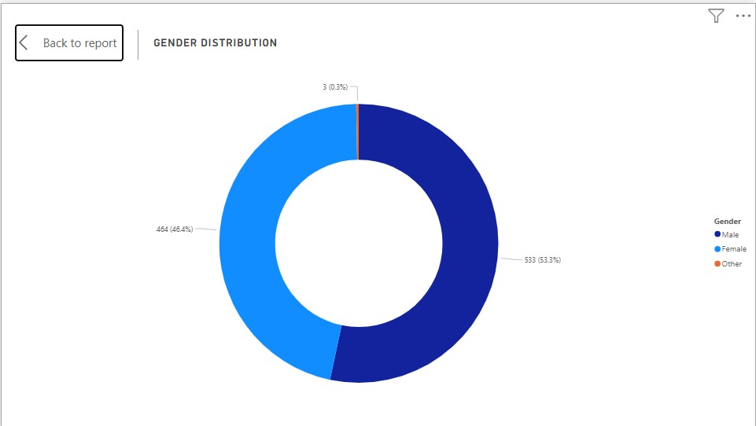

Age Group Distribution

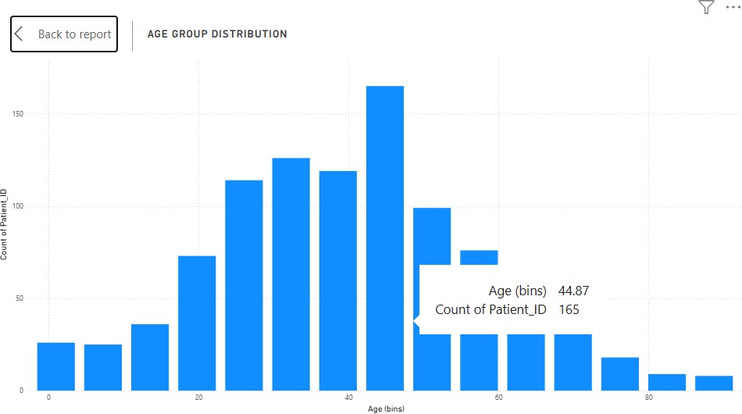
Region-wise Patient Distribution

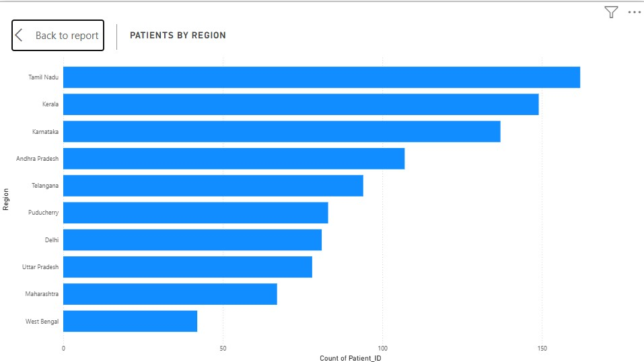

BMI Distribution

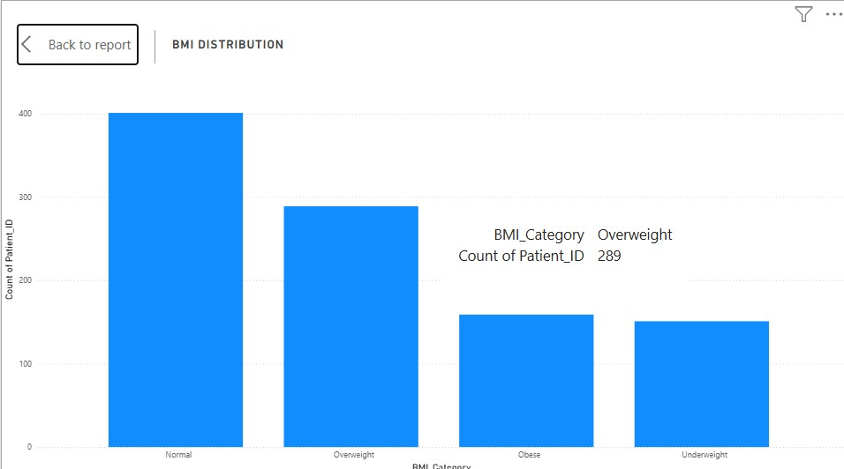
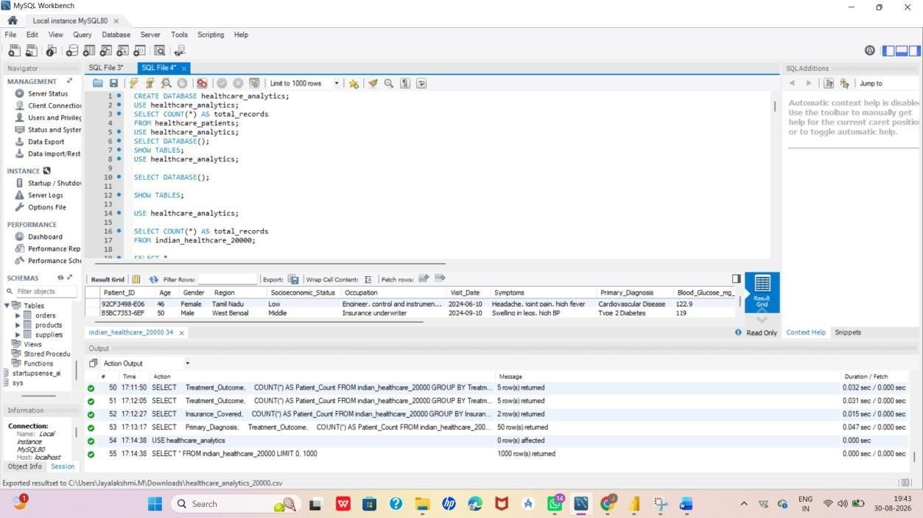

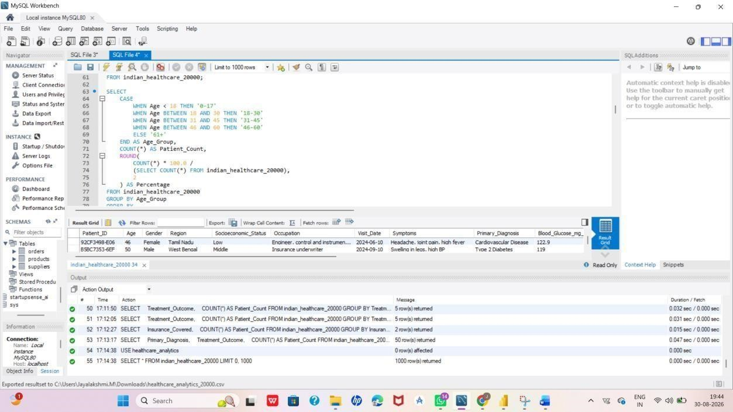

RESULT:
Thus, the Indian healthcare data was successfully analyzed using MySQL and visualized using Power BI. The project helped to identify patterns in patient demographics, diseases, treatments, treatment outcomes, BMI, and insurance coverage. The interactive dashboard provides a simple and clear way to understand the healthcare data.

